**TASK 1:**

CREATE TABLE STUDENT (

Name VARCHAR(50),

Student_number INT PRIMARY KEY,

Class VARCHAR(50),

Major VARCHAR(50)

);

CREATE TABLE COURSE (

Course_name VARCHAR(50),

Course_number VARCHAR(50) PRIMARY KEY,

Credit_hours INT,

Department VARCHAR(50)

);

CREATE TABLE SECTION (

Section_identifier INT PRIMARY KEY,

Course_number VARCHAR(50),

Semester VARCHAR(50),

Year INT,

Instructor VARCHAR(50),

FOREIGN KEY (Course_number) REFERENCES COURSE(Course_number)

);

CREATE TABLE GRADE_REPORT (

Student_number INT,

Section_identifier INT,

Grade VARCHAR(5),

PRIMARY KEY (Student_number, Section_identifier),

FOREIGN KEY (Student_number) REFERENCES STUDENT(Student_number),

FOREIGN KEY (Section_identifier) REFERENCES Section(Section_identifier)

);

CREATE TABLE PREREQUISITE (

Course_number VARCHAR(50),

Prerequisite_number VARCHAR(50),

PRIMARY KEY (Course_number, Prerequisite_number),

FOREIGN KEY (Course_number) REFERENCES COURSE(Course_number),

FOREIGN KEY (Prerequisite_number) REFERENCES COURSE(Course_number)

);

# add data

-- Insert data into STUDENT table

INSERT INTO STUDENT (Name, Student_number, Class, Major) VALUES

('Smith', 17, '1', 'CS'),

('Brown', 8, '2', 'CS');

INSERT INTO COURSE (Course_name, Course_number, Credit_hours, Department) VALUES

('Intro to Computer Science', 'CS1310', 4, 'CS'),

('Data Structures', 'CS3320', 4, 'CS'),

('Discrete Mathematics', 'MATH2410', 3, 'MATH'),

('Database', 'CS3380', 3, 'CS')

;

INSERT INTO SECTION (Section_identifier, Course_number, Semester, Year, Instructor) VALUES

(85, 'MATH2410', 'Fall', 07, 'King'),

(92, 'CS1310', 'Fall', 07, 'Anderson'),

(102, 'CS3320', 'Spring', 08, 'Knuth'),

(112, 'MATH2410', 'Fall', 08, 'Chang'),

(119, 'CS1310', 'Fall', 08, 'Anderson'),

(135, 'CS3380', 'Fall', 08, 'Stone')

;

INSERT INTO GRADE_REPORT (Student_number, Section_identifier, Grade) VALUES

(17, 112, 'B'),

(17, 119, 'C'),

(8, 85, 'A'),

(8, 92, 'A'),

(8, 102, 'B'),

(8, 135, 'A')

;

INSERT INTO PREREQUISITE (Course_number, Prerequisite_number) VALUES

('CS3380', 'CS3320'),

('CS3380', 'MATH2410'),

('CS3320', 'CS1310')

;

# a

SELECT DISTINCT Course_name, Instructor

FROM COURSE JOIN SECTION

ON COURSE.Course_number = SECTION.Course_number;

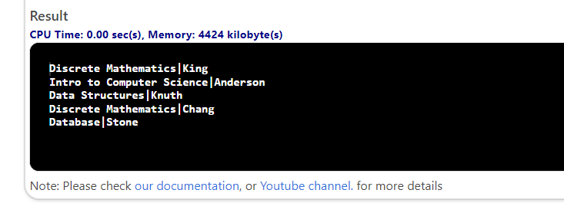

# b

SELECT SECTION.Section_identifier, Student_number, SECTION.Course_number, Semester, Year

FROM COURSE JOIN SECTION

ON COURSE.Course_number = SECTION.Course_number

JOIN GRADE_REPORT

ON SECTION.Section_identifier = GRADE_REPORT.Section_identifier;

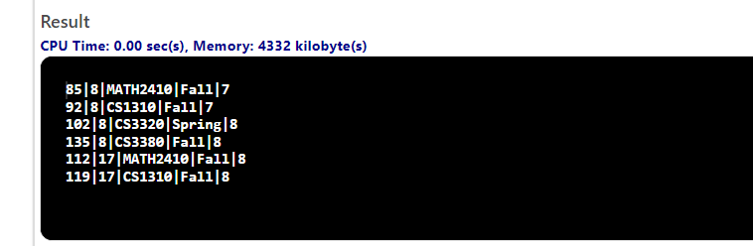

# c

SELECT Name, STUDENT.Student_number, Major,

COUNT(GRADE_REPORT.section_identifier) AS Number_of_sections

FROM STUDENT JOIN GRADE_REPORT

ON STUDENT.Student_number = GRADE_REPORT.Student_number

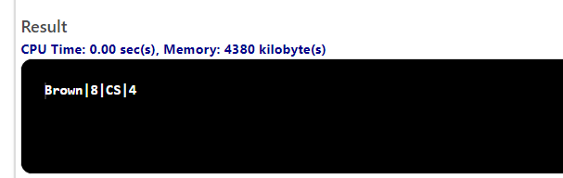GROUP BY Name, STUDENT.Student_number, Major

HAVING COUNT(Section_identifier) > 2;

**TASK 2:**

There are several steps to convert the **Entity Relation Diagram** to **Relational Schema**. First, we must look for strong entities, primary key (PK) constraints, and weak entities.

**Strong Entities**

* Bank Entity

|  |  |  |
| --- | --- | --- |
| Code (PK) | Name | Address |

* Loan Entity

|  |  |  |
| --- | --- | --- |
| Loan Number (PK) | Amount | Type |

* Account Entity

|  |  |  |
| --- | --- | --- |
| Account Number (PK) | Balance | Type |

* Customer Entity

|  |  |  |  |
| --- | --- | --- | --- |
| SSN (PK) | Name | Address | Phone |

**Weak Entities**

* Bank_Branch Entity

|  |  |
| --- | --- |
| Branch Number (PK) | Address |

Now, we have to look for the relationships between the entities, **1:1**, **1:N**, **M:N**, and **Multi-Valued Attributes**. Since there are no 1:1 and Multi-Valued Attributes, so we only convert 1:N and M:N binary relationships into relations.

**Conversion of 1:N**

As Bank and Bank_Branch have a 1:N relation, add the Primary Key (PK) of the Bank entity into the Bank_Branch entity, which is Foreign Key(FK) for Bank_Branch. A similar goes for Bank_Branch and Account entities as well as for Bank_Branch and Loan entities

* Bank_Branch Entity

|  |  |  |
| --- | --- | --- |
| Branch Number (PK) | Address | Code (FK) |

* Account Entity

|  |  |  |  |
| --- | --- | --- | --- |
| Account Number (PK) | Balance | Type | Branch Number (FK) |

* Loan Entity

|  |  |  |  |
| --- | --- | --- | --- |
| Loan Number (PK) | Amount | Type | Branch Number (FK) |

**Conversion of M:N**

**Converting M:N Relationship means creating a new Entity with the relationship name and adding primary keys of both entities along with descriptive attributes if had.**

* Customers_Account Entity

|  |  |
| --- | --- |
| Account Number (FK refers from Account) | Customer SSN (SSN refers from Customer) |

* Customers_loan Entity

|  |  |
| --- | --- |
| Loan Number (FK refers from Loan) | Customer SSN (SSN refers from Customer) |

**Final Relational Schema**

* Bank Entity

|  |  |  |
| --- | --- | --- |
| Code (PK) | Name | Address |

* Bank_Branch Entity

|  |  |  |
| --- | --- | --- |
| Branch Number (PK) | Address | Code (FK) |

* Account Entity

|  |  |  |  |
| --- | --- | --- | --- |
| Account Number (PK) | Balance | Type | Branch Number (FK) |

* Loan Entity

|  |  |  |  |
| --- | --- | --- | --- |
| Loan Number (PK) | Amount | Type | Branch Number (FK) |

* Customer Entity

|  |  |  |  |
| --- | --- | --- | --- |
| SSN (PK) | Name | Address | Phone |

* Customers_Account Entity

|  |  |
| --- | --- |
| Account Number (FK refers from Account) | Customer SSN (SSN refers from Customer) |

* Customers_loan Entity

|  |  |
| --- | --- |
| Loan Number (FK refers from Loan) | Customer SSN (SSN refers from Customer) |